**Lang graph:**

In my previous post :

<https://www.linkedin.com/posts/dsp1729_ai-machinelearning-openai-activity-7205741303840608256-F60Q?utm_source=share&utm_medium=member_desktop>

I built an Agent from Scratch using only Python and LLM but now we will implement the same using Lan graph

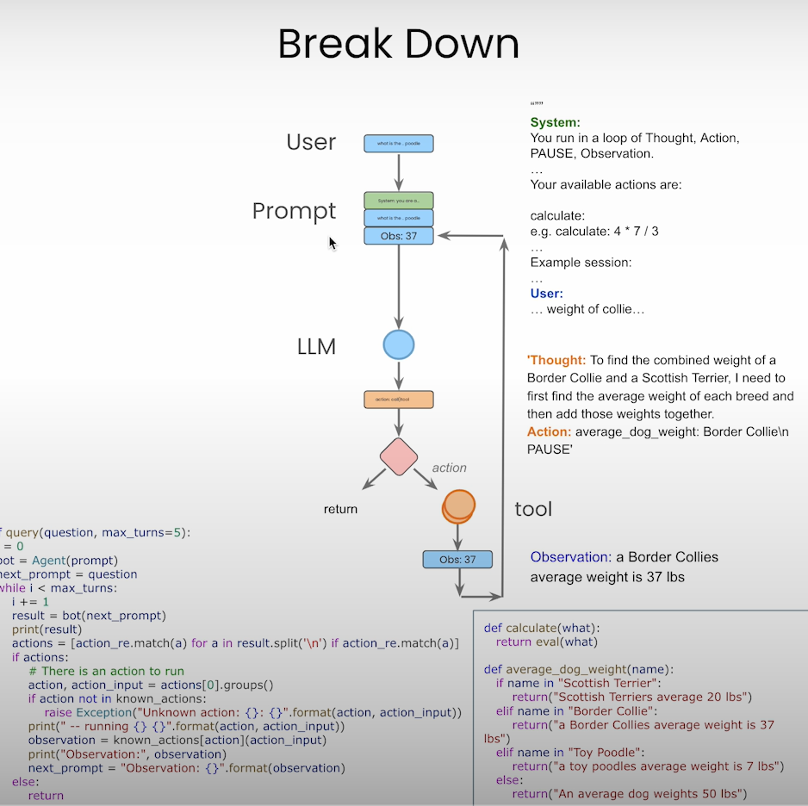

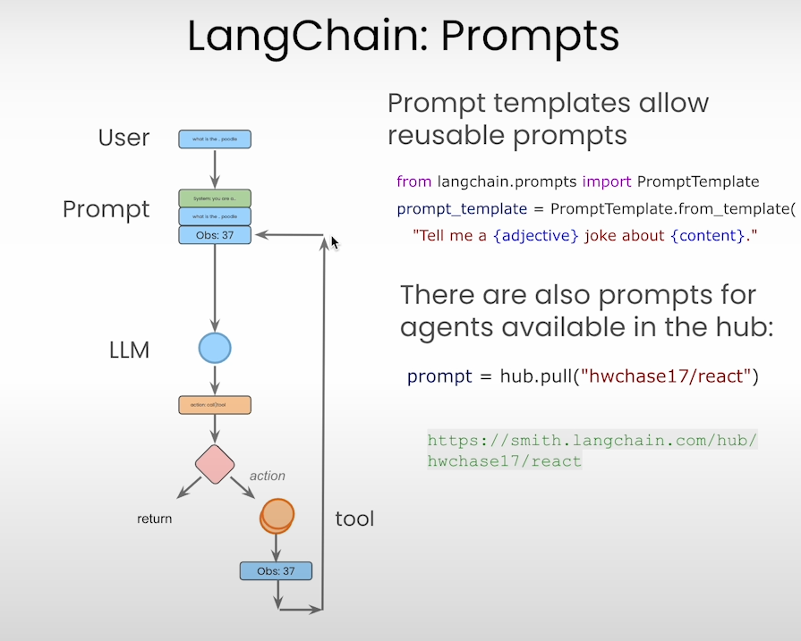

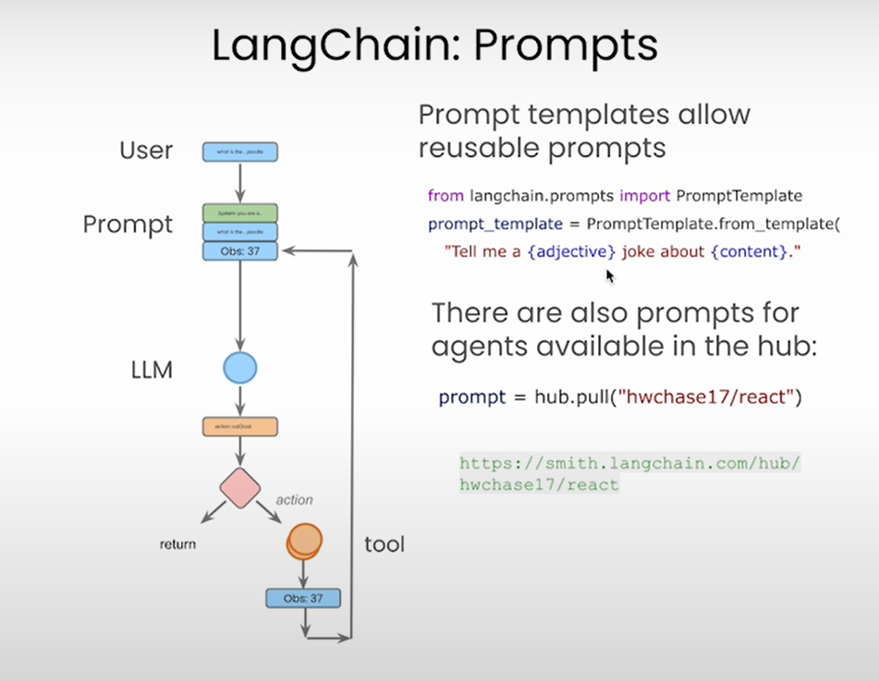

Prompt Templates are reusable components to use and we can format them however we want

Here are some of the examples:

<https://smith.langchain.com/hub/hwchase17/react>  
 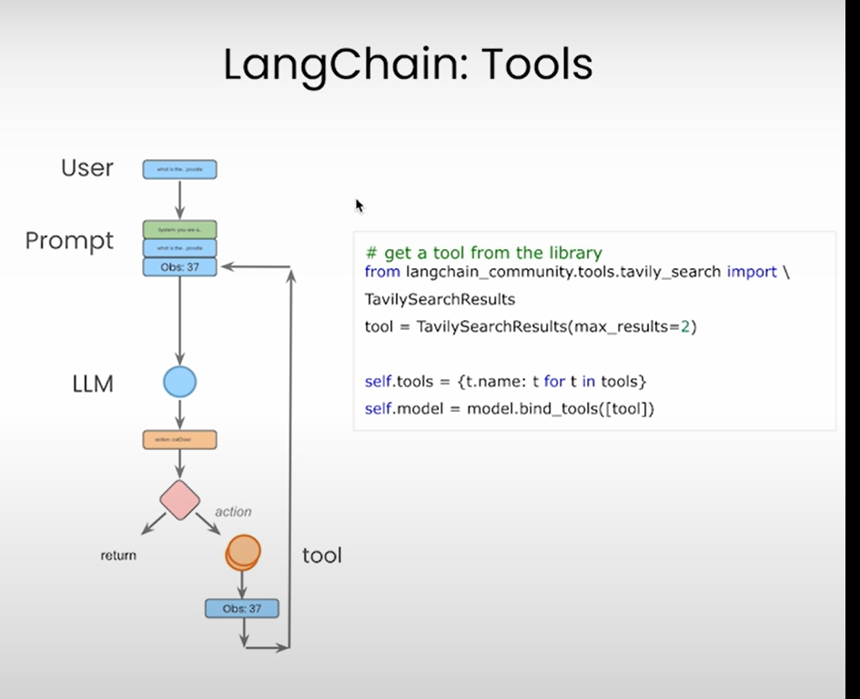

Tavily Tool for Search 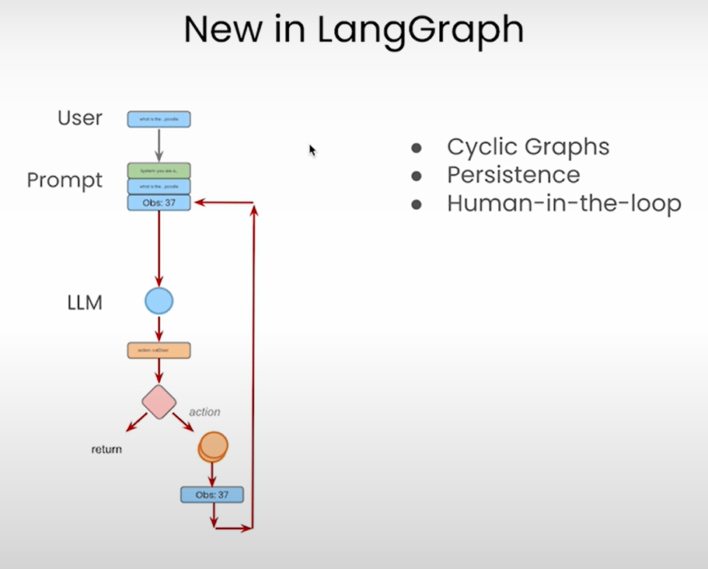

Lan graph helps you to strive and orchestrate.

Lang graph helps to describe and Orchestrate the Control Flow. It allows to create Cyclic Graphs.

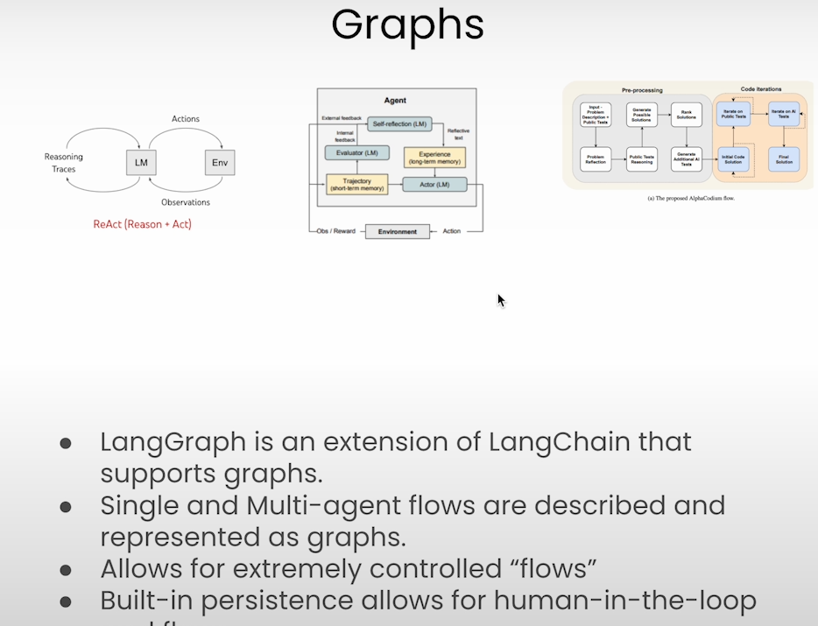

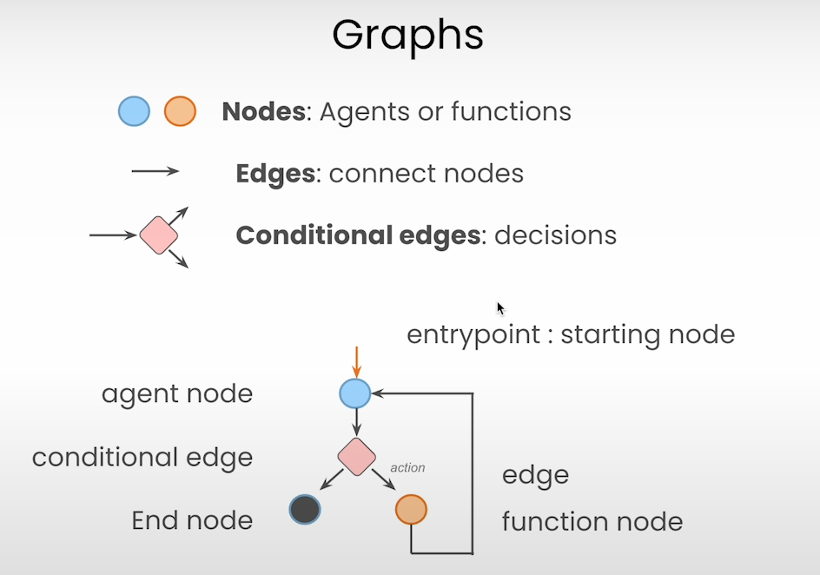

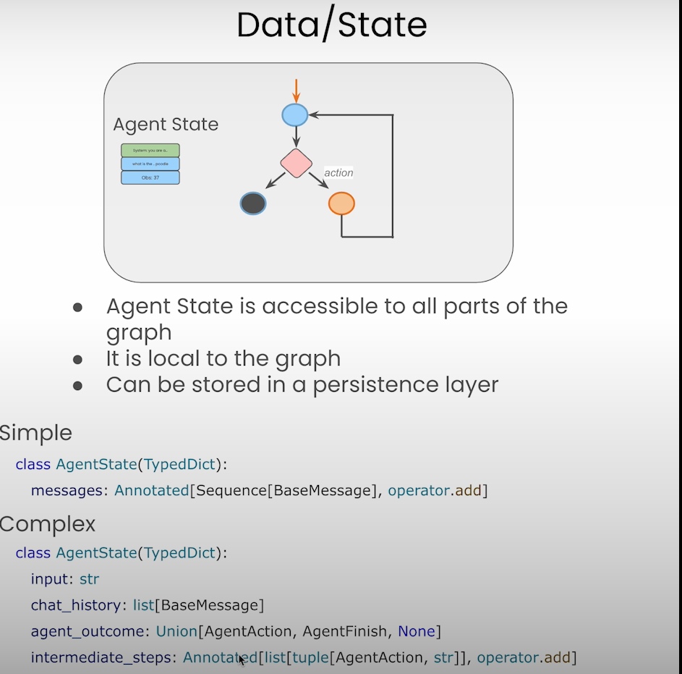

Here intermediate_steps are annotated

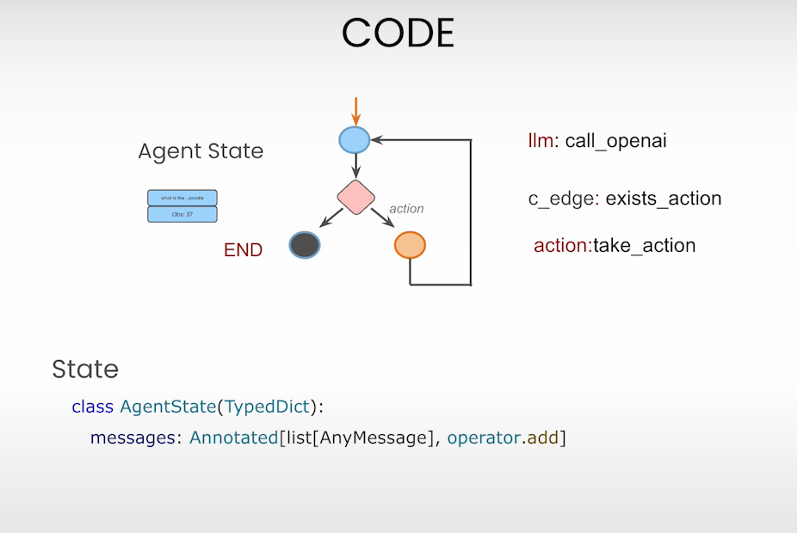

Tavily Search

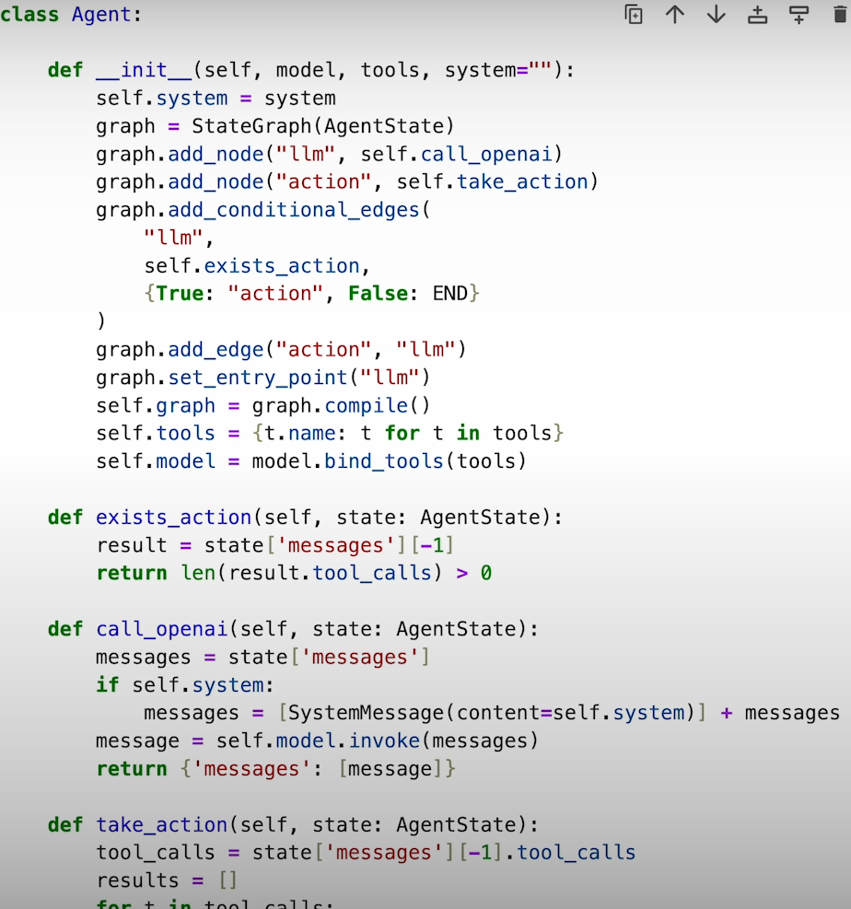

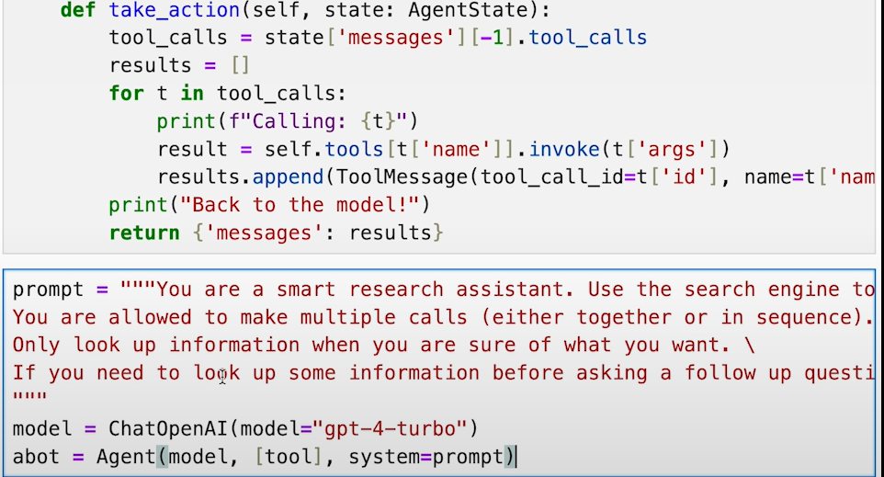

Let’s visualize the graph we had created:

